Nama : Andri Firman Saputra  
NIM : 201011402125  
Kelas : 05TPLP016  
Tugas : Basis Data II – Latihan 7

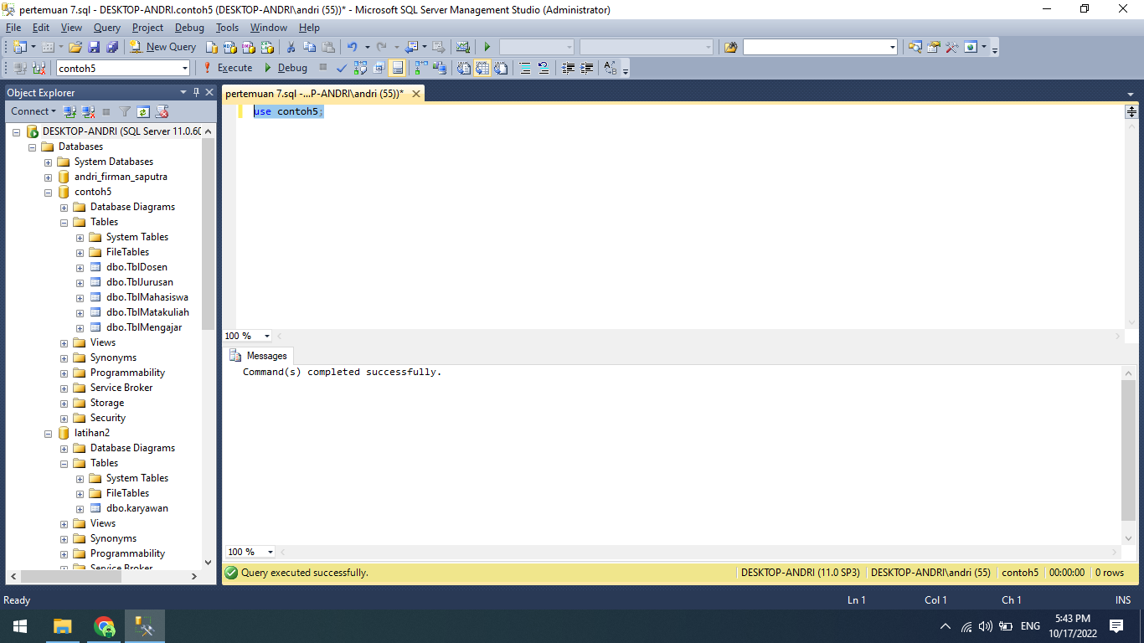

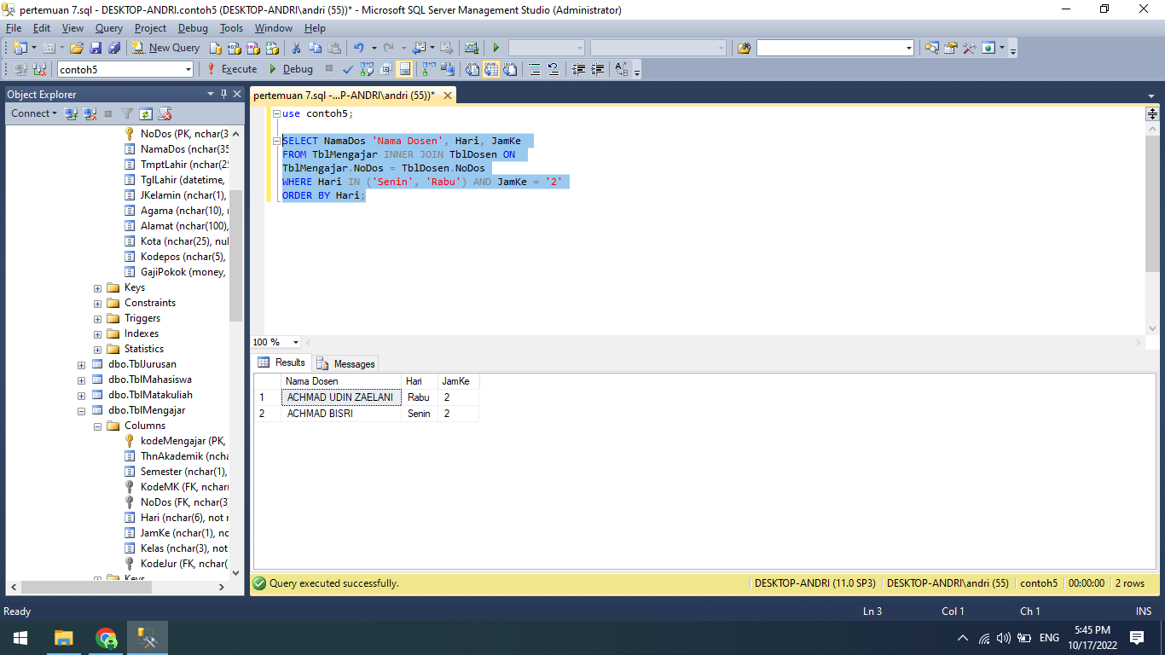

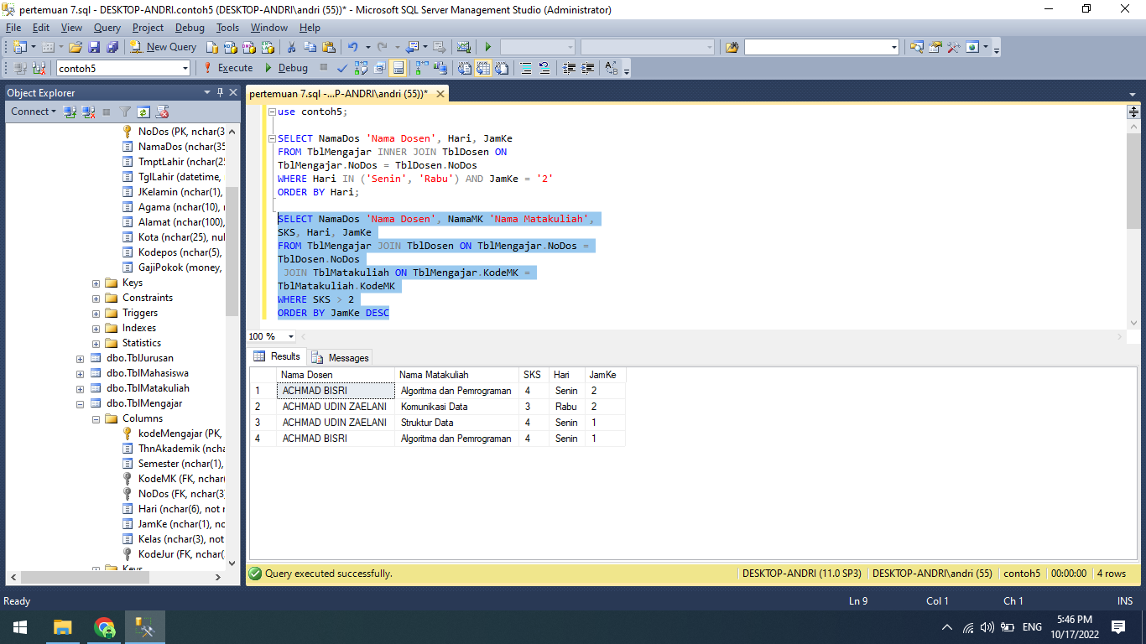

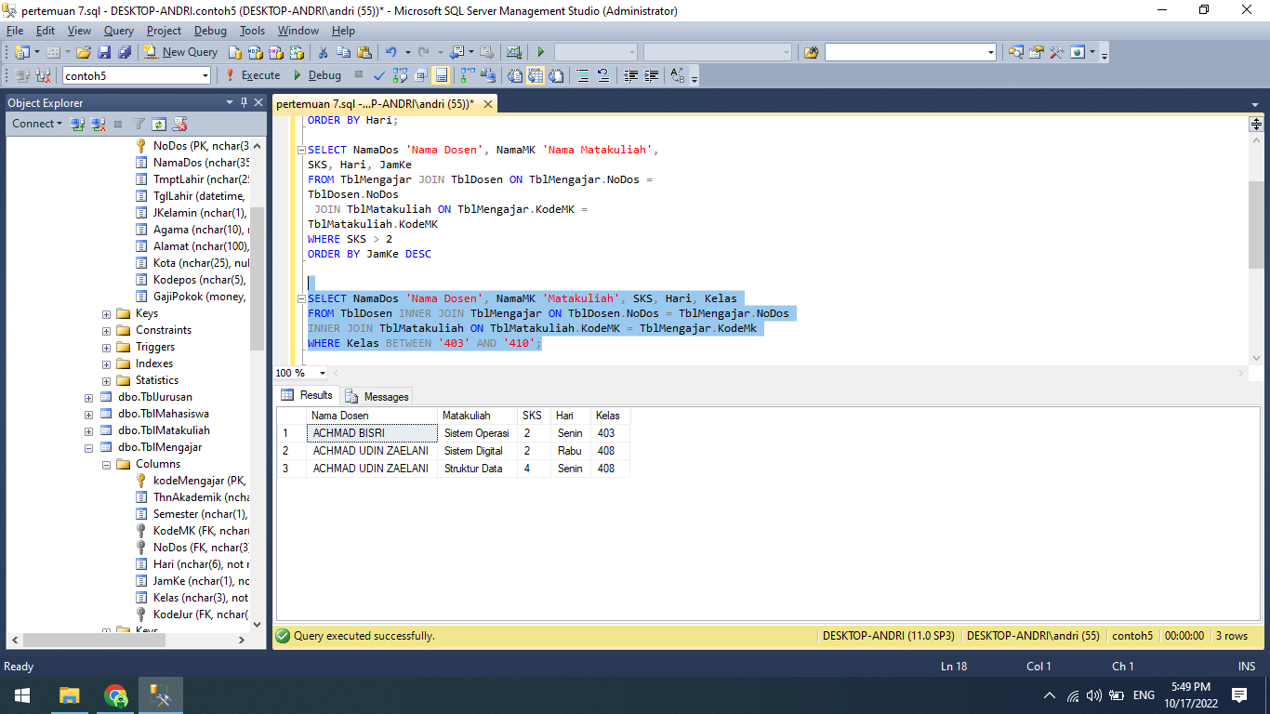

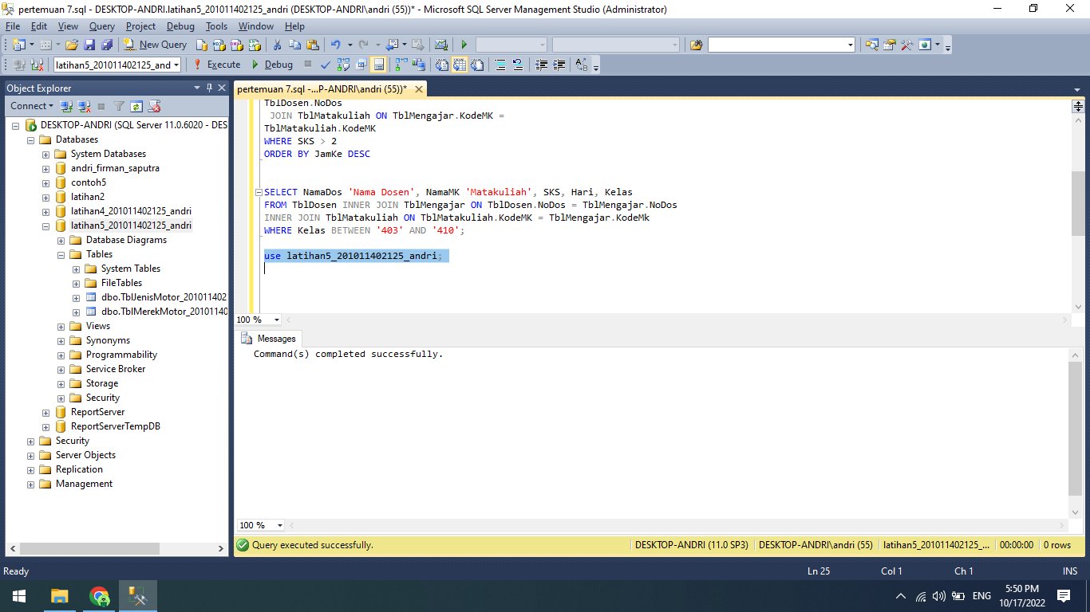

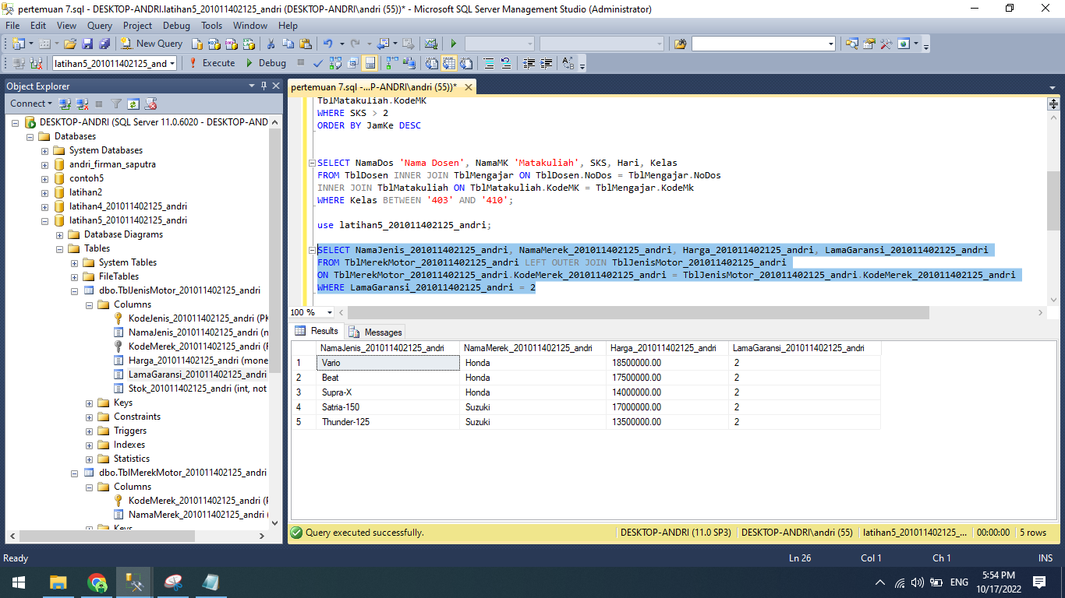

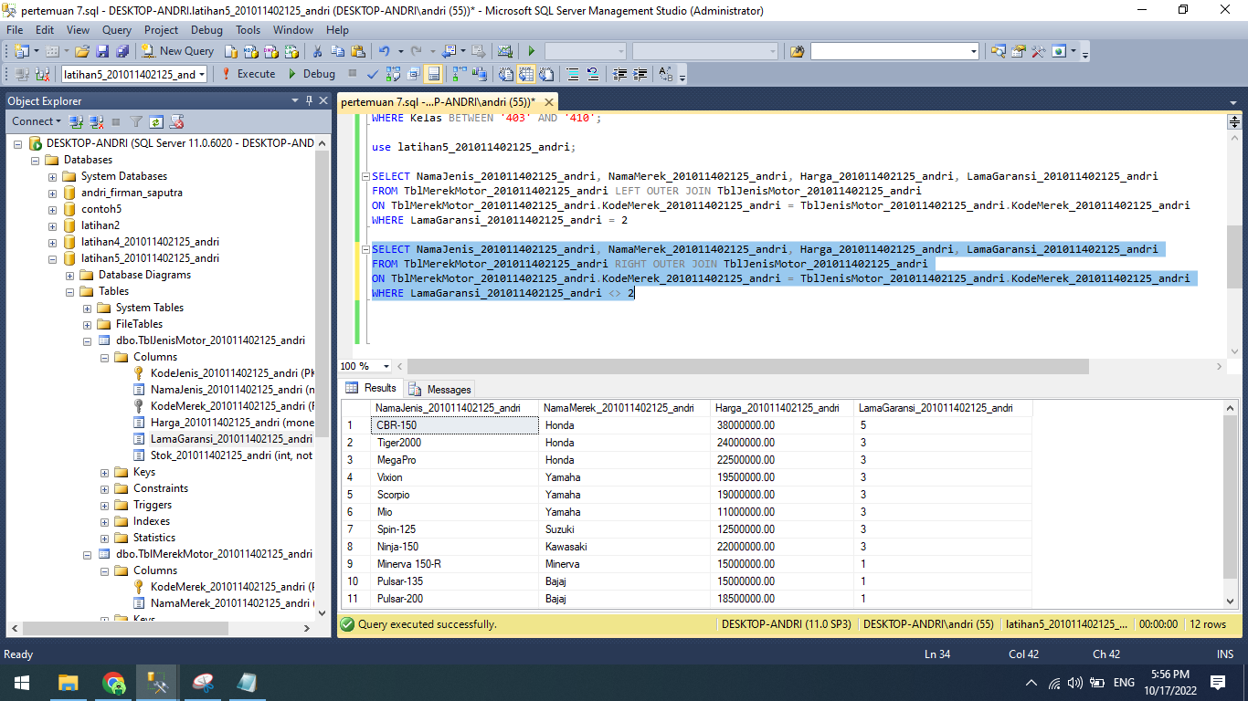

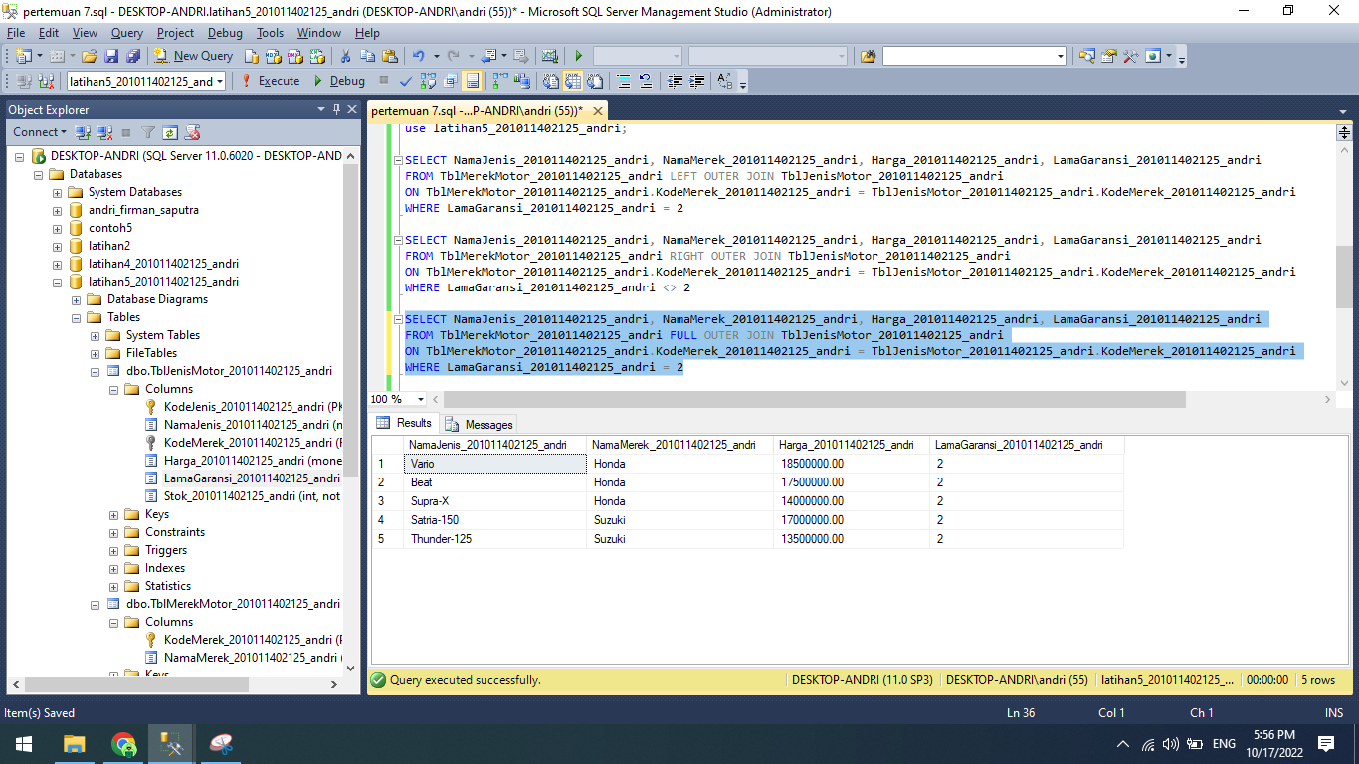

Source Code:

use contoh5;

SELECT NamaDos 'Nama Dosen', Hari, JamKe

FROM TblMengajar INNER JOIN TblDosen ON

TblMengajar.NoDos = TblDosen.NoDos

WHERE Hari IN ('Senin', 'Rabu') AND JamKe = '2'

ORDER BY Hari;

SELECT NamaDos 'Nama Dosen', NamaMK 'Nama Matakuliah',

SKS, Hari, JamKe

FROM TblMengajar JOIN TblDosen ON TblMengajar.NoDos =

TblDosen.NoDos

JOIN TblMatakuliah ON TblMengajar.KodeMK =

TblMatakuliah.KodeMK

WHERE SKS > 2

ORDER BY JamKe DESC;

SELECT NamaDos 'Nama Dosen', NamaMK 'Matakuliah', SKS, Hari, Kelas

FROM TblDosen INNER JOIN TblMengajar ON TblDosen.NoDos = TblMengajar.NoDos

INNER JOIN TblMatakuliah ON TblMatakuliah.KodeMK = TblMengajar.KodeMk

WHERE Kelas BETWEEN '403' AND '410';

use latihan5_201011402125_andri;

SELECT NamaJenis_201011402125_andri, NamaMerek_201011402125_andri, Harga_201011402125_andri, LamaGaransi_201011402125_andri

FROM TblMerekMotor_201011402125_andri LEFT OUTER JOIN TblJenisMotor_201011402125_andri

ON TblMerekMotor_201011402125_andri.KodeMerek_201011402125_andri = TblJenisMotor_201011402125_andri.KodeMerek_201011402125_andri

WHERE LamaGaransi_201011402125_andri = 2;

SELECT NamaJenis_201011402125_andri, NamaMerek_201011402125_andri, Harga_201011402125_andri, LamaGaransi_201011402125_andri

FROM TblMerekMotor_201011402125_andri RIGHT OUTER JOIN TblJenisMotor_201011402125_andri

ON TblMerekMotor_201011402125_andri.KodeMerek_201011402125_andri = TblJenisMotor_201011402125_andri.KodeMerek_201011402125_andri

WHERE LamaGaransi_201011402125_andri <> 2;

SELECT NamaJenis_201011402125_andri, NamaMerek_201011402125_andri, Harga_201011402125_andri, LamaGaransi_201011402125_andri

FROM TblMerekMotor_201011402125_andri FULL OUTER JOIN TblJenisMotor_201011402125_andri

ON TblMerekMotor_201011402125_andri.KodeMerek_201011402125_andri = TblJenisMotor_201011402125_andri.KodeMerek_201011402125_andri

WHERE LamaGaransi_201011402125_andri = 2;